
ОБЩЕСТВО С ОГРАНИЧЕННОЙ ОТВЕТСТВЕННОСТЬЮ
«ЛАЗЕРТАГ»

ПАСПОРТ

Смоленск

SPECIFICATION

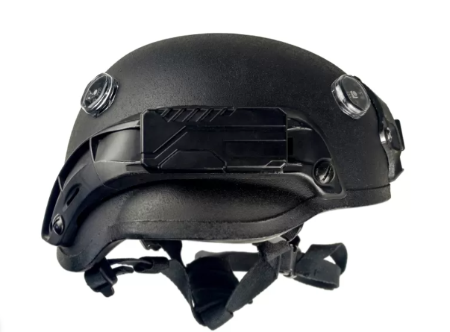

Tactical Ops-Core helmet for laser tag v.11 Alphatag

Dear Customer!
LASERTAG LLC welcomes you and thanks you for choosing our products, and also expresses confidence that the product you purchased will bring you pleasure and will last a long time. This coupon establishes a warranty liability for the product in the amount provided by the Law of the Russian Federation "On Protection of Consumer Rights".
This warranty card is valid for 12 months from the date of purchase of the product subject to the terms of the guarantee.

2
11
7. Contact information
Official site:
www.laserwar.com

Email:
help@laserwar.com

Skype:
help@laserwar.com

_____________________
signature

- Purpose
A helmet with defeat sensors is an essential part of gaming laser tag set. It is connected with laser tag gun with the help of wireless bluetooth connection and it is used to indicate the player's affected area.

- Technical specifications
Connection type | Wireless
Weight | 0,85 kg
Battery Type | Li+;  2,9 Аh
Type of charger | automatic, Li+
Battery life | до 36 hours

- Delivery set
№ | Name | Unit of measurement | Quantity
1. | Ops-Core helmet with defeat sensors v.11 Alphatag | pcs. | 1
2. | Manual | pcs. | 1

3
10

Date of purchase:_______________

Information about the repairs carried out during the period of guaranteed service (to be filled in by the service center performing the warranty repair)

Date:__________________Completed work:  _____________________________________________________________________  Printing Service Center | Date:__________________  Completed work:  _____________________________________________________________________  Printing Service Center
Date:__________________Completed work:  _____________________________________________________________________  Printing Service Center | Date:__________________Completed work:  _____________________________________________________________________  Printing Service Center
Date:__________________Completed work:  _____________________________________________________________________  Printing Service Center | Date:__________________Completed work:  _____________________________________________________________________  Printing Service Center

- Description and work
  - Gadget
The basic unit is Ops-Core helmet, that has good functionality. Shock-absorbing tabs are attached to its inner part with the help of "Velcro". Helmet mounts help to install night vision device, also there are guides for installing a helmet lamp, an action camera and a Velcro panel. Belts system is fully adjustable and will satisfy any user. Five sensors provide a 360° horizontal and 180° vertical angle of impact.
The helmet system with defeat sensors is shown in the diagram.

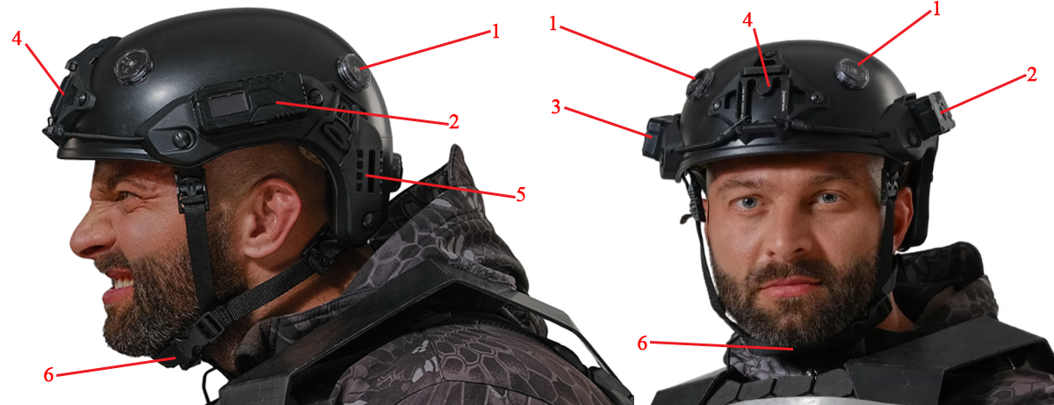
1. Hit sensors;
2. Control unit;
3. Battery pack;
4. Forehead fastening
5. Side mounts
6. Chin strap

4
9
  - Changing of the tactical and technical characteristics of the gaming set
There is no change in the tactical and technical characteristics for a helmet with defeat sensors.

  - Getting ready for work

Tactical Ops-Core helmet for lasertag v.11 Alphatag is turned on with the help of the clock button, located on the control unit, and with the help of the Bluetooth-channel is connected with the tagger.
The activation of the game kit takes place using the remote control (the "New Game" command), the "First aid kit" or the control program of the arena via a Wi-Fi connection. After activation, the game kit is ready for use.

Terms of guarantee:

1. The guarantee becomes effective upon presenting the present coupon, which indicates the date of purchase of the equipment, confirmed by the service center.
2. These warranty obligations apply to products purchased only from an official representative of LLC LASERTAG, or its Official Dealer.
3. This warranty is void if defects in the product have occurred in the event of:
- non-observance of Instructions for use;
- mechanical damage;
- ingress of foreign objects, liquids, etc .;
- animal activities;
- unauthorized access to sites and details of persons who are not authorized to carry out specified actions;
- use of the product for purposes for which it is not provided;
- acts of force majeure (natural catastrophe, fire, accident, etc.);
- failure of the product due to improper connection, a faulty electrical outlet and / or poor maintenance of the product.
4. If the warranty card is lost, the duplicate does not issue.

5
8
6
7
5. Rules of operation

When using dressings, you should pay attention to the need for special hygiene cuffs that protect electronic components from moisture. If during the use of SMART RGB-dressing gets wet, it can lead to the failure of the electro-nick - the dressing should be dried immediately.
In addition, when using dressings, you may encounter mechanical damage to the covers that protect the sensors. In such cases, the covers must be replaced.
Store the equipment in a well-ventilated room at temperatures between + 18 ° C and + 30 ° C and relative humidity between 45 and 65%.
Store the equipment only in a charged state (at the rated voltage of the battery).
1. Weather conditions. We strongly advise against using the equipment in rain and temperatures below -20 ° C. Avoid moisture entering the sensors. If this happens - stop operation, pour the equipment at room temperature for at least 2 hours.
In no case can not immediately put on charge equipment, used at low temperatures. It is necessary to allow the electronics to warm up, to dry the condensate, which occurs when the weather conditions change sharply.
2. Accumulators. As a power source in a wireless SMART RGB bandage, a lithium polymer battery of 1.8 Ah capacity is used. For its recharging, it is necessary to use only the universal auto-charger Li +.
First of all, you need to connect the charger to the device, and then - to the network.
The recharging process can be monitored using a special indicator on the charger. If the ac-accumulator is discharged - the LED lights red; At the end of the charging process, the color of the glow changes to green.
Attention! Recharge the dressing immediately after use under constant supervision at an ambient temperature of at least 0 ° C for no more than 180 minutes.

6. Warranty

The manufacturer guarantees the reliability of operation of the individual set of "LASERWAR" while observing the operating conditions by the consumer. The manufacturer undertakes to replace or repair the individual set of equipment free of charge, provided that the rules of transportation, storage, operation and payment for the delivery of faulty equipment to the city of Smolensk are followed by the consumer.
On the batteries, speakers, IR modules, the warranty is 14 DAYS.
ATTENTION! In the event of improper use of batteries (charging by an inappropriate type of charger), the battery warranty does not apply! With full technical guidance on the operation of laser tag equipment by LA-SERWAR, you can see on our website www.laserwar.com.

